**Clock generator code**

module square_wavegen

(

i_clock,

i_enable,

i_switch_1,

o_clock_freq

);

input i_clock;

input i_enable;

input i_switch_1;

output o_clock_freq;

// Constants (parameters) to create the frequencies needed:

// Input clock is 100 MHz, i.e of the chosen FPGA

// Formula is: (100 MHz / 600 Hz * 50% duty cycle) for 600hz frequency

// So for 1MHz: 100Mhz / 1Mhz* 0.5 = 49

parameter c_CNT_600HZ = 83334;

parameter c_CNT_1MHZ = 49;

// These signals will be the counters:

reg [31:0] r_CNT_600HZ = 0;

reg [31:0] r_CNT_1MHZ = 0;

// These signals will toggle at the frequencies needed:

reg r_TOGGLE_600HZ = 1'b0;

reg r_TOGGLE_1MHZ = 1'b0;

// One bit select

reg r_CLOCK_SELECT;

wire w_CLOCK_SELECT;

begin

// All always blocks toggle a specific signal at a different frequency.

// They all run continuously even if the switches are

// not selecting their particular output.

always @ (posedge i_clock)

begin

if (r_CNT_600HZ == c_CNT_600HZ-1) // -1, since counter starts at 0

begin

r_TOGGLE_600HZ <= !r_TOGGLE_600HZ;

r_CNT_600HZ <= 0;

end

else

r_CNT_600HZ <= r_CNT_600HZ + 1;

end

always @ (posedge i_clock)

begin

if (r_CNT_1MHZ == c_CNT_1MHZ-1) // -1, since counter starts at 0

begin

r_TOGGLE_1MHZ <= !r_TOGGLE_1MHZ;

r_CNT_1MHZ <= 0;

end

else

r_CNT_1MHZ <= r_CNT_1MHZ + 1;

end

// Create a multiplexer based on switch inputs

always @ (*)

begin

case (i_switch_1)

1'b0 : r_CLOCK_SELECT <= r_TOGGLE_600HZ;

1'b1 : r_CLOCK_SELECT <= r_TOGGLE_1MHZ;

endcase

end

assign o_clock_freq = r_CLOCK_SELECT & i_enable;

end

endmodule

**TESTBENCH (600hz)**

module tb();

reg i_clock,i_enable,i_switch_1;

wire o_clock_freq;

square_wavegen inst1 (.i_clock(i_clock),.i_enable(i_enable),.i_switch_1(i_enable),.o_clock_freq(o_clock_freq));

initial

i_clock = 1'b0;

always

#5 i_clock = ~i_clock;

initial

begin

i_enable = 1; i_switch_1 = 0;

end

endmodule

**TESTBENCH (1.023MHz)**

module tb();

reg i_clock,i_enable,i_switch_1;

wire o_clock_freq;

square_wavegen inst1 (.i_clock(i_clock),.i_enable(i_enable),.i_switch_1(i_enable),.o_clock_freq(o_clock_freq));

initial

i_clock = 1'b0;

always

#5 i_clock = ~i_clock;

initial

begin

i_enable = 1; i_switch_1 = 1;

end

endmodule

**SIMULATION CAPTURE**

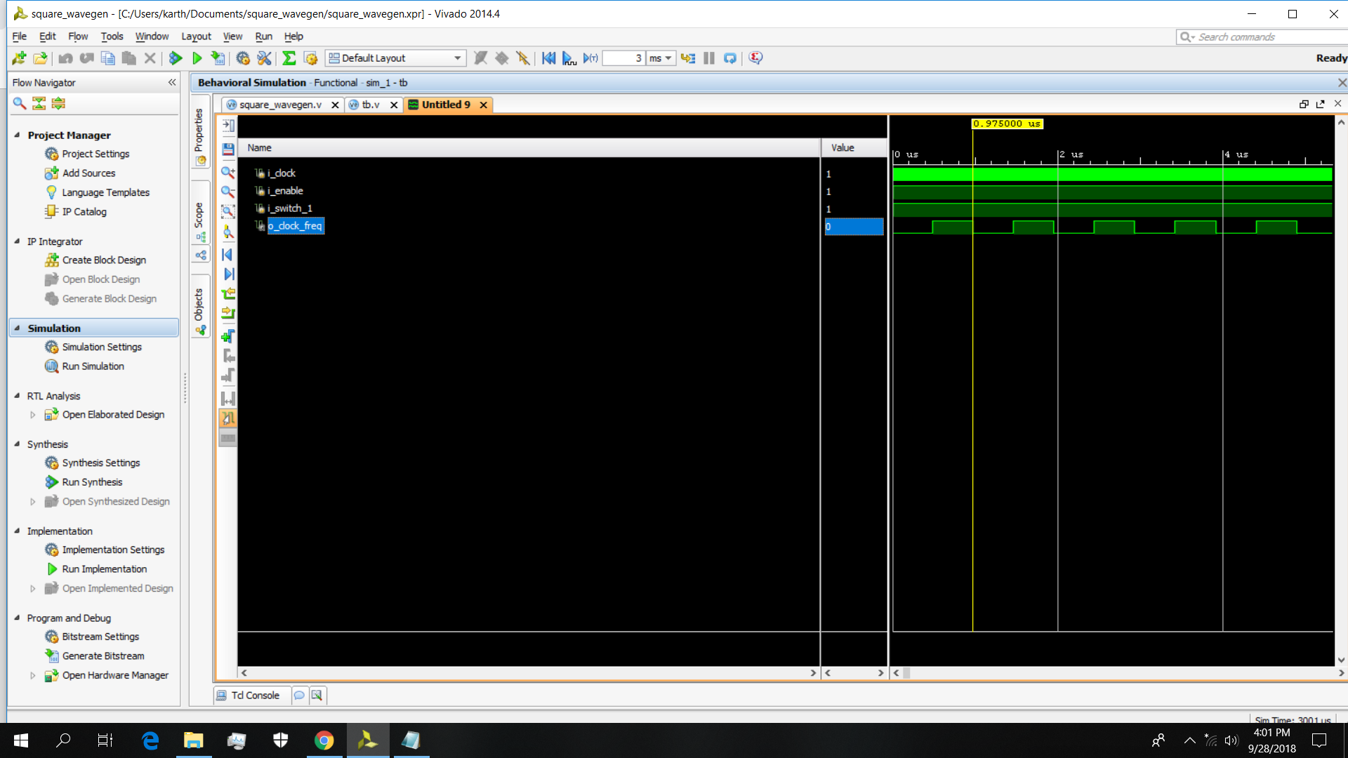

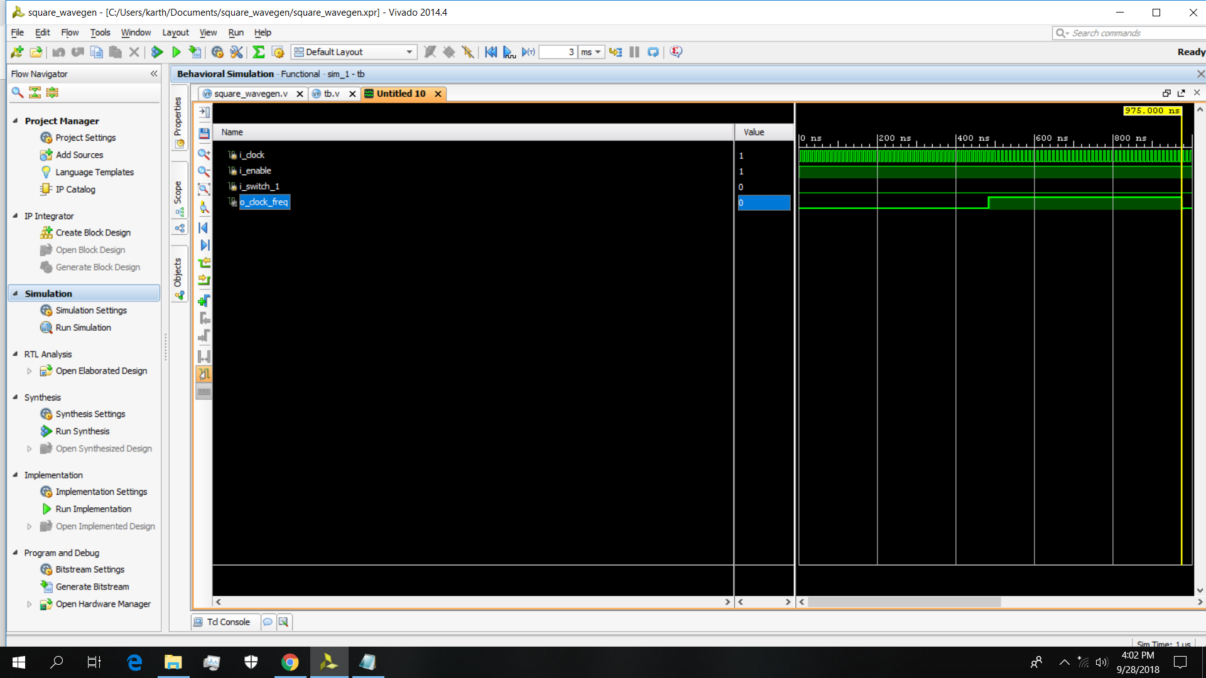

**RTL DESIGN**

